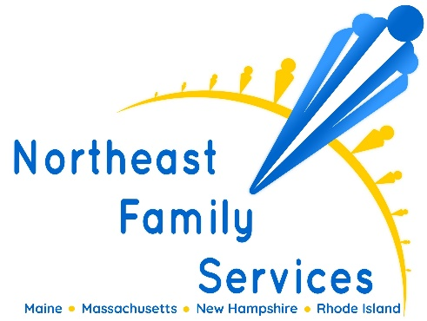
We are currently seeking enthusiastic and compassionate Board Certified Behavior Analysts (BCBA) to provide home-based ABA services to children and adolescents. The BCBA will be responsible for the completion of behavioral assessments, short and long-term consultations and direct treatment with a focus on skill acquisition and behavior reduction.
Responsibilities
- Complete behavioral assessments and develop each client’s behavior support plan; work with clients, families, direct support staff, and the community to implement the client's behavior support plan
- Conduct weekly supervision with all direct support staff to ensure proper implementation of the behavior support plan and provide training and guidance as needed
- Provide parent training, resources and guidance in behavioral interventions and the basics of ABA in order to support the client’s behavior plan
- Setup, Collect and graph data for each goal/objective in a behavior support plan; update the behavior support plan appropriately
- Complete and review all necessary documentation (i.e. supervision summaries, program updates, overlaps, etc.)
- Responsible for the oversight of all treatment, treatment updates, documentation and resources related to the clients support plan
Required Experience
- Current BCBA Certification
- Current LABA License
- Minimum of two (2) years’ experience working with children & adolescents with autism, other developmental disabilities, and behavioral problems
- Experience in applied settings developing and implementing behavioral interventions
- Experience with Vineland, ABLLS-R or other related assessments
- Effective written and verbal communication skills
- Proficient in Word and Excel
- Valid driver’s license with reliable and consistent access to a vehicle
- Availability to work morning, after school and evening hours
- Bilingual candidates who can speak Spanish, Portuguese, Creole, Mandarin or Cantonese are a plus

Full Time Benefits
- Flexible Schedule
- Health & Dental
- Paid vacation & sick time
- 9 paid holidays
- 401k retirement plan with 3% matching after 1 year of employment
- Tuition Assistance
- Referral bonuses
- Company provided laptop and cell phone
- 2 paid days per year to attend seminars, conferences or trainings
- Free supervision for certification/Licensure
- ACE provider for Continuing Education (CEU's)

Compensation
- Full time Salary range $65,000 - $75,000
- Fee for Service range $60 - $75 hourly

