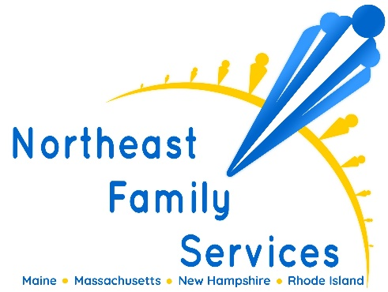
Are you looking for a rewarding career helping children, families and adults? Are you interested in working for a dynamic organization that is invested in their clients and staff?
Northeast Family Services is looking for an energetic, self-directed individual to serve as Program Director for our Children's Behavioral Health Initiative Services. The Program Director will report to the Clinical Director and is responsible to provide leadership and oversee the daily operations of the outpatient, in-home therapy, and therapeutic mentoring programs. The Program Director will guide the staff and assist in the development, treatment, methodologies and ensuring the effective implementation of all in-home treatment and programming for our clients.
Responsibilities
- Serve as liaison between the Clinical Director and staff; serve as liaison between the agency and other service agencies
- Provide direct clinical supervision to program therapists and paraprofessional staff regarding clinical strategies, client treatment planning and implementation of services
- Provide leadership, motivation and direction to foster teamwork among the staff
- Respond to parent/caregiver/family concerns and determine appropriate resolutions
- Ensure compliance with Federal, State and agency guidelines related to administrative and clinical policies
- Participate in Directors’ Meeting, Clinical Team Meeting and other meetings as assigned
- Participate in Performance Improvement activities; assist Clinical Director by recommending changes/revisions to policy guidelines
- Participate in the interview process and makes recommendations for hiring clinical staff
- Assist with staff orientation, training and evaluations, train new staff on billing protocol, productivity requirements and agency policy
Required Experience
- Must be licensed (LMHC, LMFT, LICSW, Licensed Psychologist)
- Master's degree in related field
- Five years minimum experience working with behavioral-emotional disorders or children with Autism Spectrum Disorder
- Valid driver’s license with reliable and consistent access to a vehicle
Benefits
- Health & Dental
- Paid vacation & sick time
- 9 paid holidays
- 401k retirement plan
- Company provided laptop and cell phone

